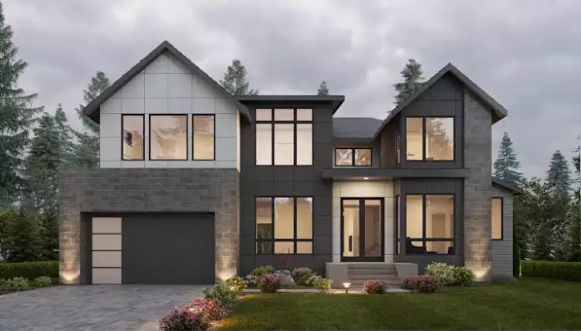  house price prediction & category prediction | Name: saira Jabeen  RoLL NO: 23-AI-10  Section: A2(B)  Semester: 5Th  Year: 3rd  Department: Artificial intelligence  Course: Machine Learning  Course instructor: engr. hamza farooqi

1. Introduction
The objective of this project was to develop a machine learning system capable of predicting house prices and categorizing houses into different price ranges. Real-world housing datasets often contain missing values and categorical attributes that require preprocessing before model training.
Two machine learning tasks were performed:
- Regression Task: Predicting the exact house sale price using Linear Regression.
- Classification Task: Categorizing houses into Low, Medium, and High price categories using Random Forest Classifier.
The project demonstrates the complete machine learning pipeline, including data preprocessing, visualization, model development, and performance evaluation.

2. Dataset Description
The project uses the House Prices dataset stored in train.csv.
The dataset contains various housing-related features such as:
- Overall Quality
- Living Area Size
- Number of Garage Spaces
- Basement Area
- Number of Bathrooms
- Sale Price
The target variable for regression is:
SalePrice
For classification, the sale prices were divided into three categories:
- Low
- Medium
- High

3. Data Preprocessing

3.1 Handling Missing Values
Missing values were identified and treated using appropriate strategies:

Numerical Features
Missing values were replaced with the median value of the corresponding feature.

Categorical Features
Missing values were replaced with the most frequent value (mode).
This ensured that no important records were lost during preprocessing.

3.2 Removing Irrelevant Features
The Id column was removed because it does not contribute to house price prediction and only serves as a unique identifier.

3.3 Encoding Categorical Variables
Machine learning algorithms require numerical inputs. Therefore, all categorical features were converted into numerical values using Label Encoding.

3.4 Feature Scaling
Feature scaling was performed using StandardScaler to standardize numerical features and improve model performance.

4. Exploratory Data Analysis
Several visualizations were created to better understand the dataset.

House Price Distribution
A histogram was generated to observe the distribution of house prices.
Observations:
- Most houses fall within the medium price range.
- The distribution is slightly right-skewed.
- High-priced houses appear less frequently.

Feature Correlation Analysis
Correlation analysis was performed to identify the most influential features affecting house prices.
Highly correlated features included:
- OverallQual
- GrLivArea
- GarageCars
- TotalBsmtSF
- FullBath
These features were selected for model development.

5. Regression Model: House Price Prediction

Algorithm Used

Linear Regression
Linear Regression was used to predict continuous house prices based on selected features.

Selected Features
- OverallQual
- GrLivArea
- GarageCars
- TotalBsmtSF
- FullBath

Model Training
The dataset was divided into:
- 80% Training Data
- 20% Testing Data
The model was trained using the training dataset and evaluated on unseen test data.

Evaluation Metrics
The following regression metrics were used:

R² Score
Measures how well the model explains variation in house prices.

Mean Absolute Error (MAE)
Measures the average prediction error.

Root Mean Squared Error (RMSE)
Measures prediction accuracy while giving more importance to larger errors.

6. Classification Model: Price Category Prediction

Category Creation
Sale prices were divided into three groups using quantiles:
Category | Description
Low | Lower-priced houses
Medium | Mid-range houses
High | Expensive houses

Algorithm Used

Random Forest Classifier
Random Forest was selected because:
- It handles complex relationships effectively.
- It reduces overfitting through ensemble learning.
- It performs well on structured datasets.

Model Training
The same important housing features were used for classification.
The dataset was split into training and testing sets before model training.

Evaluation Metrics
The classifier was evaluated using:
- Accuracy Score
- Confusion Matrix
- Classification Report
These metrics help assess how accurately the model assigns houses to the correct price category.

7. Results and Analysis

Linear Regression
The model successfully predicted house prices based on housing characteristics.
Key observations:
- Important housing features strongly influenced price prediction.
- Feature scaling improved model stability.
- The model provided a good baseline for regression analysis.

Random Forest Classifier
The classification model effectively categorized houses into Low, Medium, and High price groups.
Key observations:
- High classification accuracy was achieved.
- Random Forest handled feature interactions efficiently.
- Ensemble learning improved robustness and generalization.

8. Challenges and Solutions
Challenge | Solution
Missing values | Median and mode imputation
Categorical features | Label Encoding
Different feature scales | StandardScaler
Risk of overfitting | Random Forest ensemble approach
Feature selection | Correlation-based analysis

9. Conclusion
This project successfully implemented both regression and classification techniques for housing data analysis. Data preprocessing, visualization, feature engineering, and machine learning models were combined to create a complete predictive system.
Linear Regression was used to estimate house prices, while Random Forest Classifier categorized properties into price ranges. Proper handling of missing values, feature scaling, and encoding significantly improved model performance.
The project demonstrates practical applications of machine learning in real-estate analytics and predictive modeling.

Technologies Used
- Python
- Pandas
- NumPy
- Matplotlib
- Seaborn
- Scikit-Learn

Models Used
- Linear Regression
- Random Forest Classifier

